**PROJECT REPORT TEMPLATE**

**Build an Event Management System**

**1.INTRODUCTION:**

**1.1 OVERVIEW:**

Event management is the process of creating and maintaining an event. This process spans from the very beginning of planning all the way to post-event strategizing.

1.2 Purpose:

* Planning of Event: As an administrator, you can create events in Salesforce.
* Add Contacts to the Event The Event Manager can add participants to an event from within Salesforce

.

* Portal For Self-register for the event Thanks to WordPress, we were able to create a page that automatically displays all active events.

2. problem definition & design thinking:

2.1 empathy map

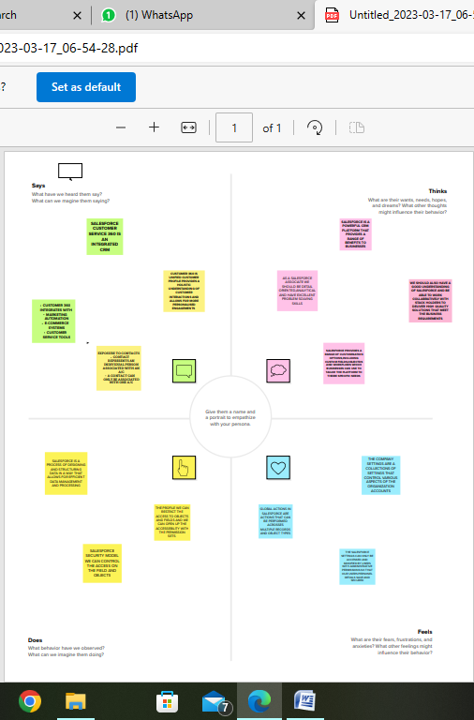

2.2 ideation & brainstorming map

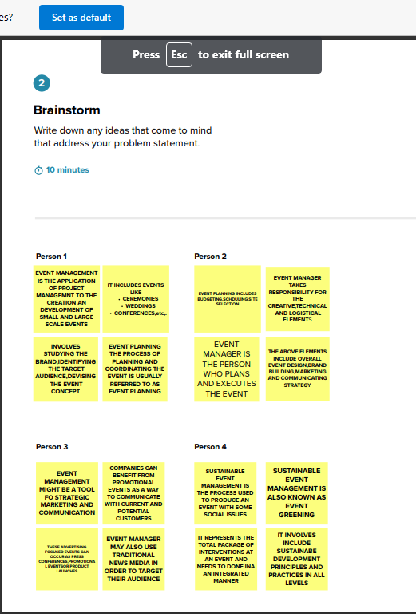

3.result:

3.1 data model:

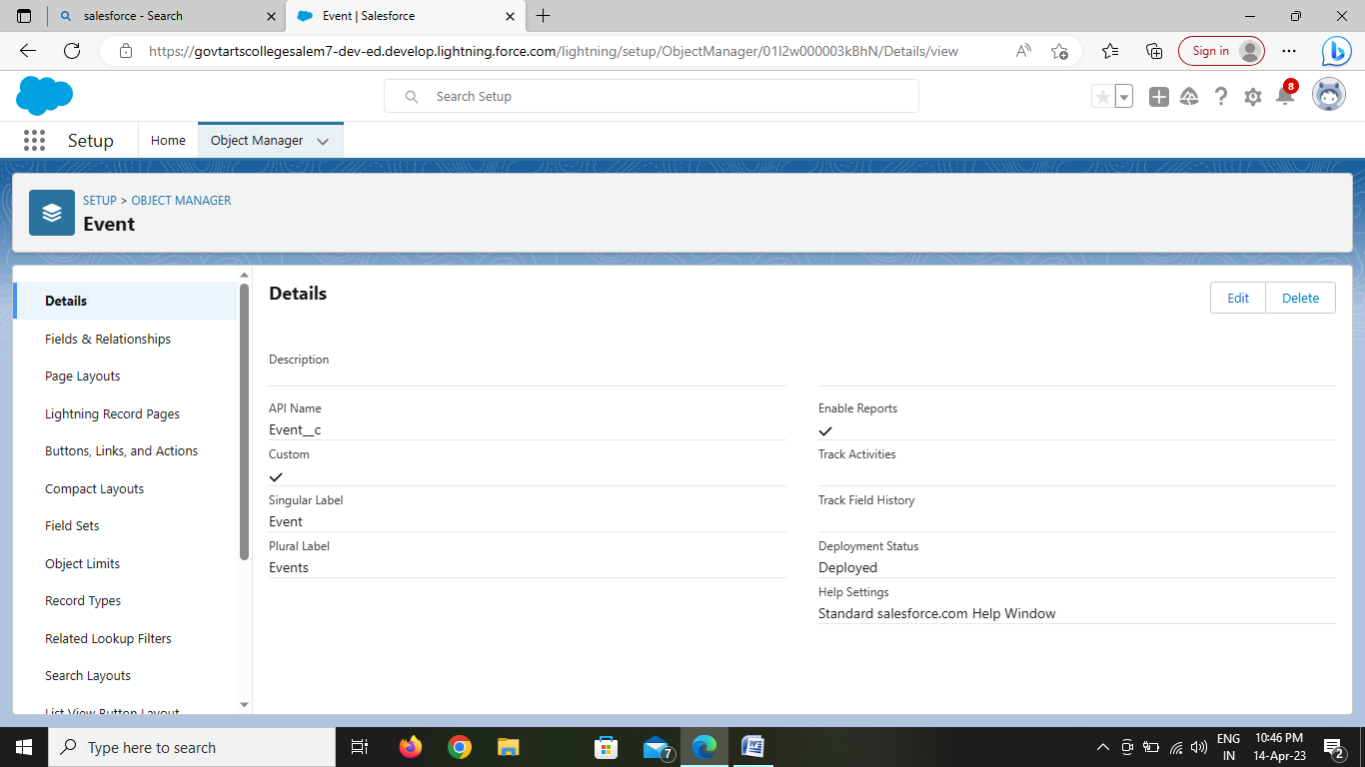

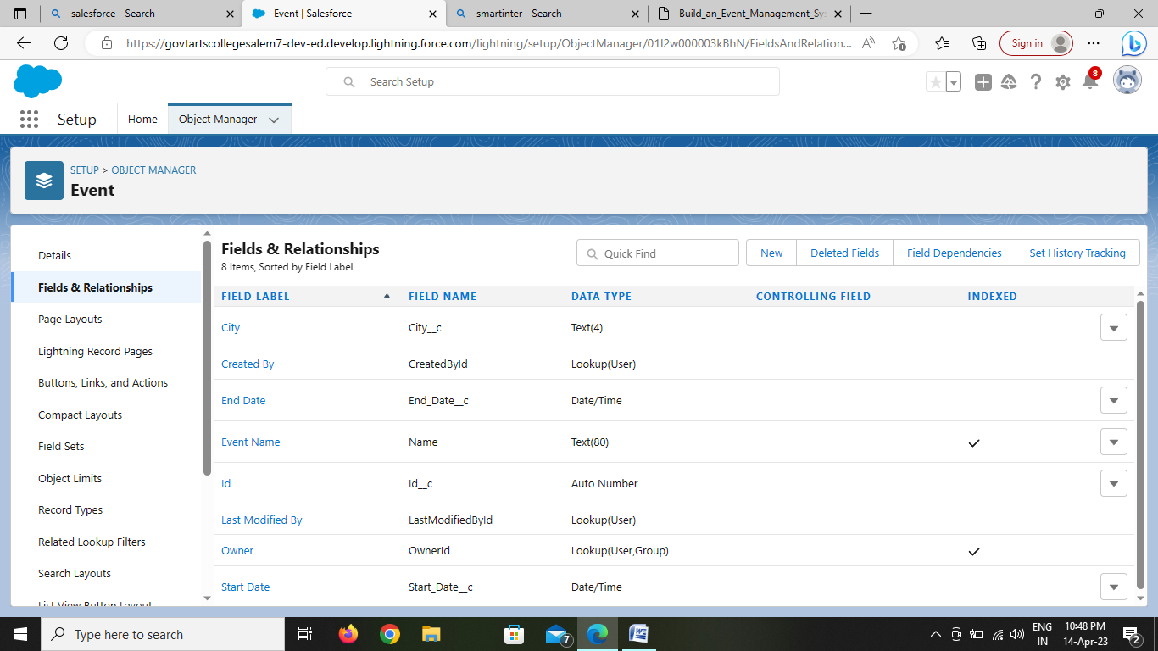

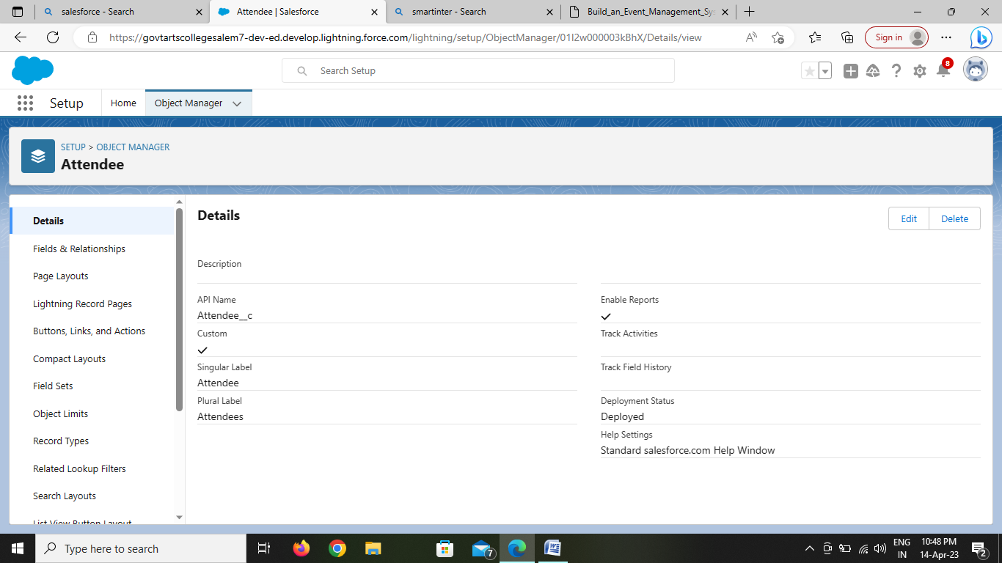

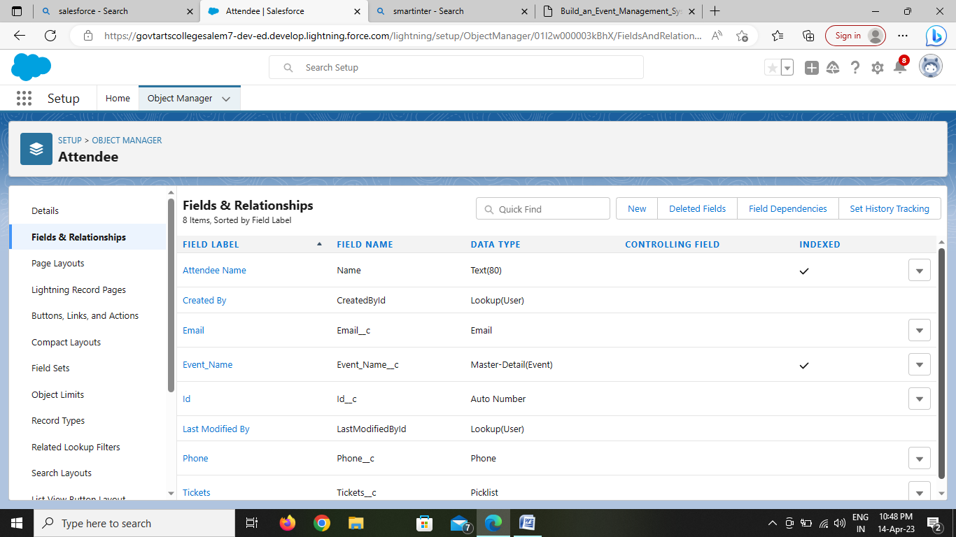

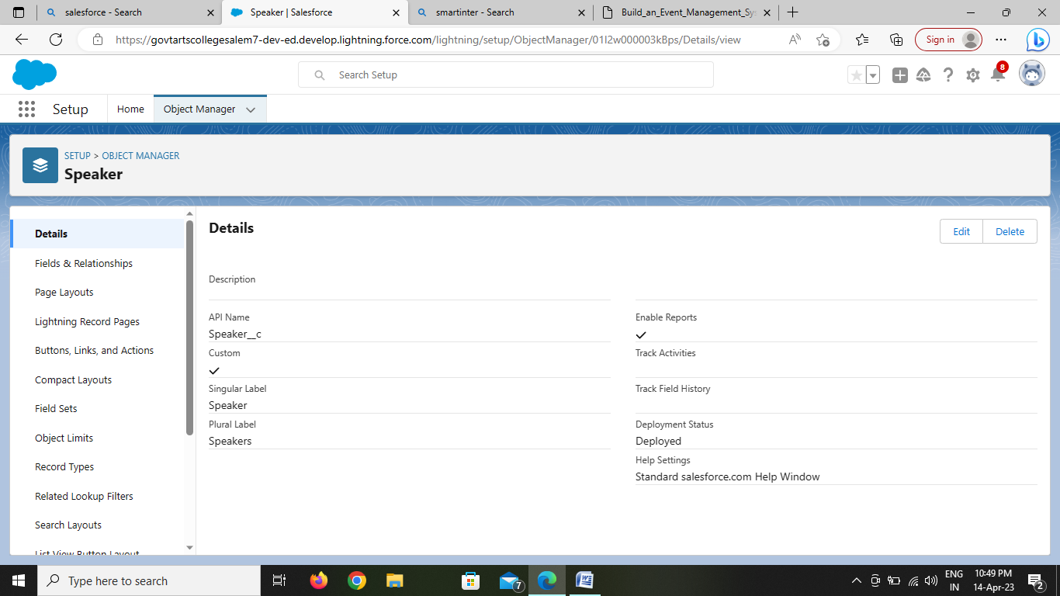

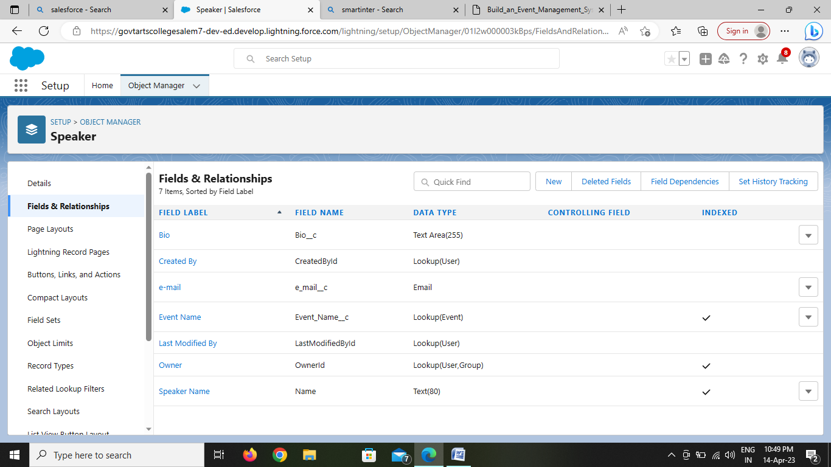

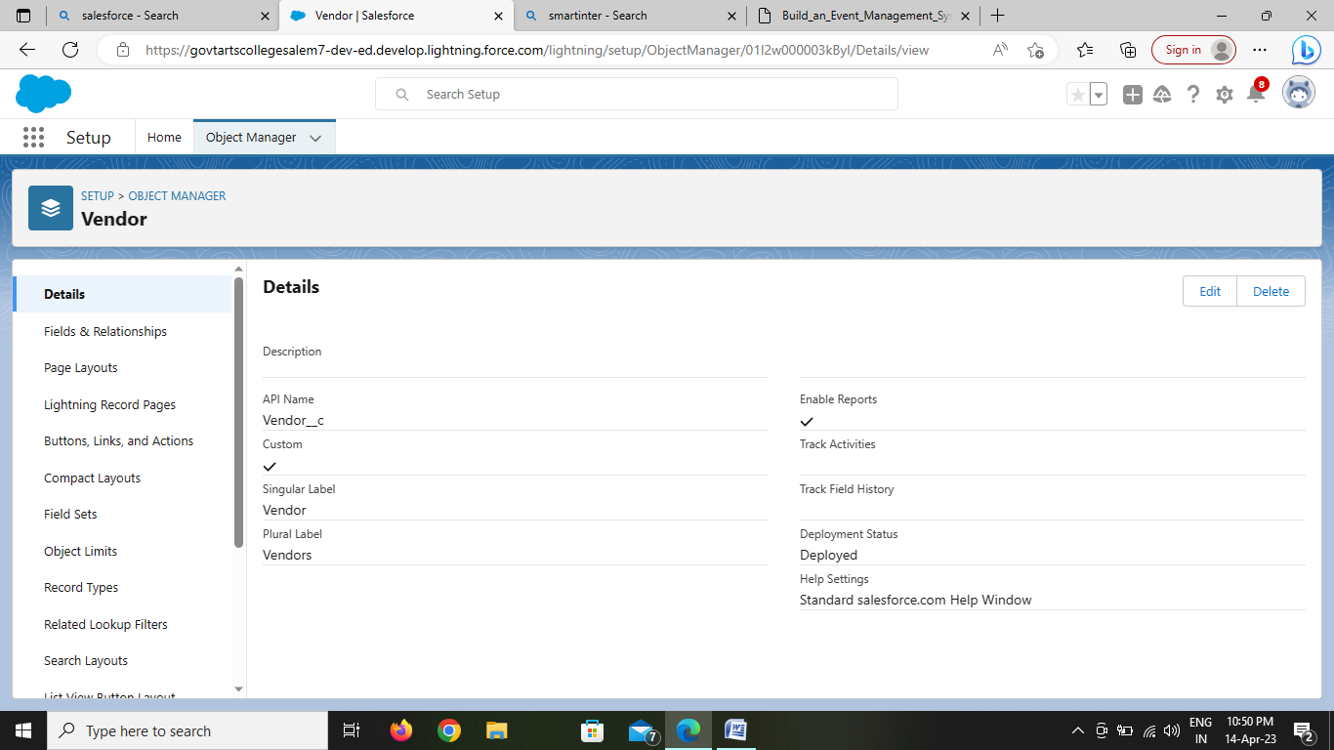

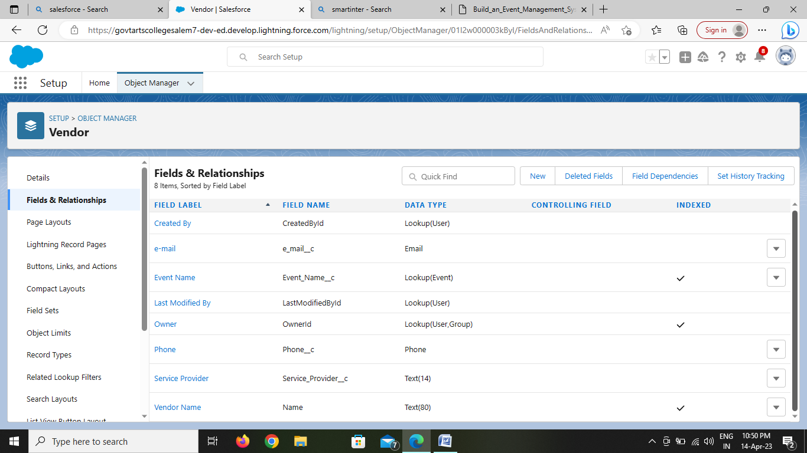

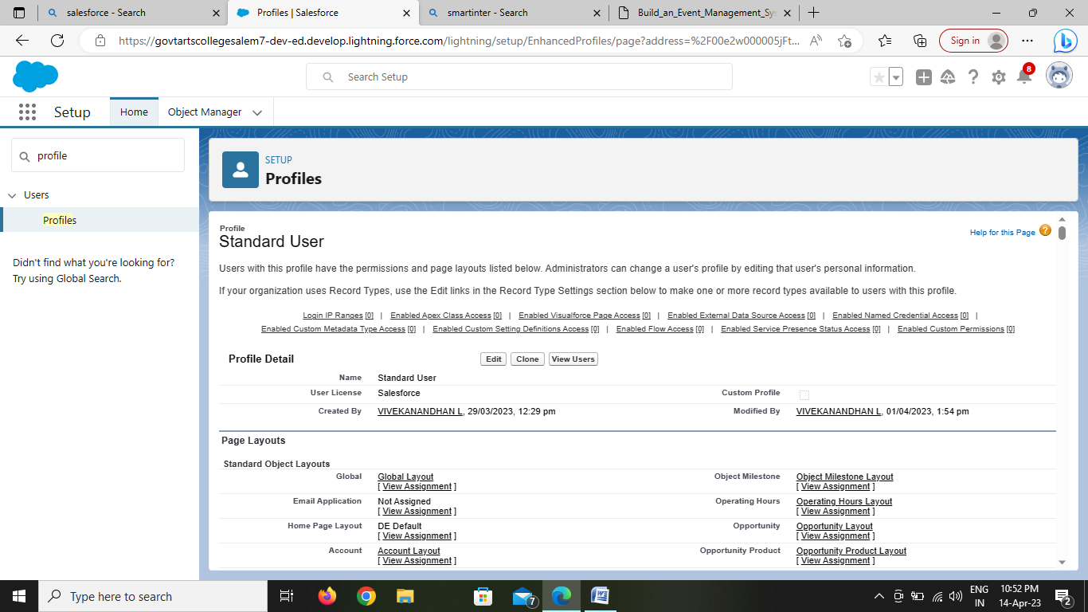

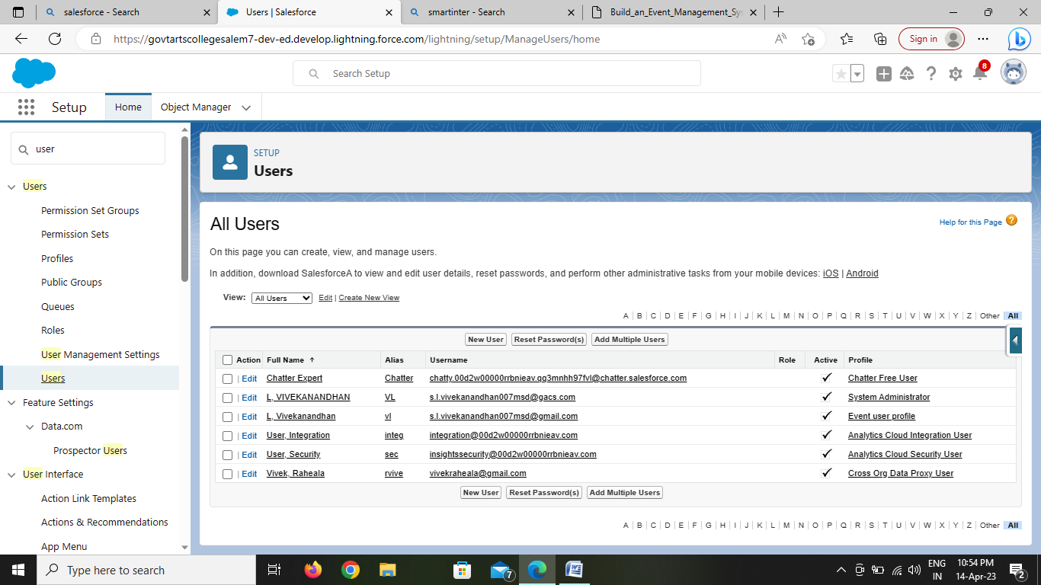

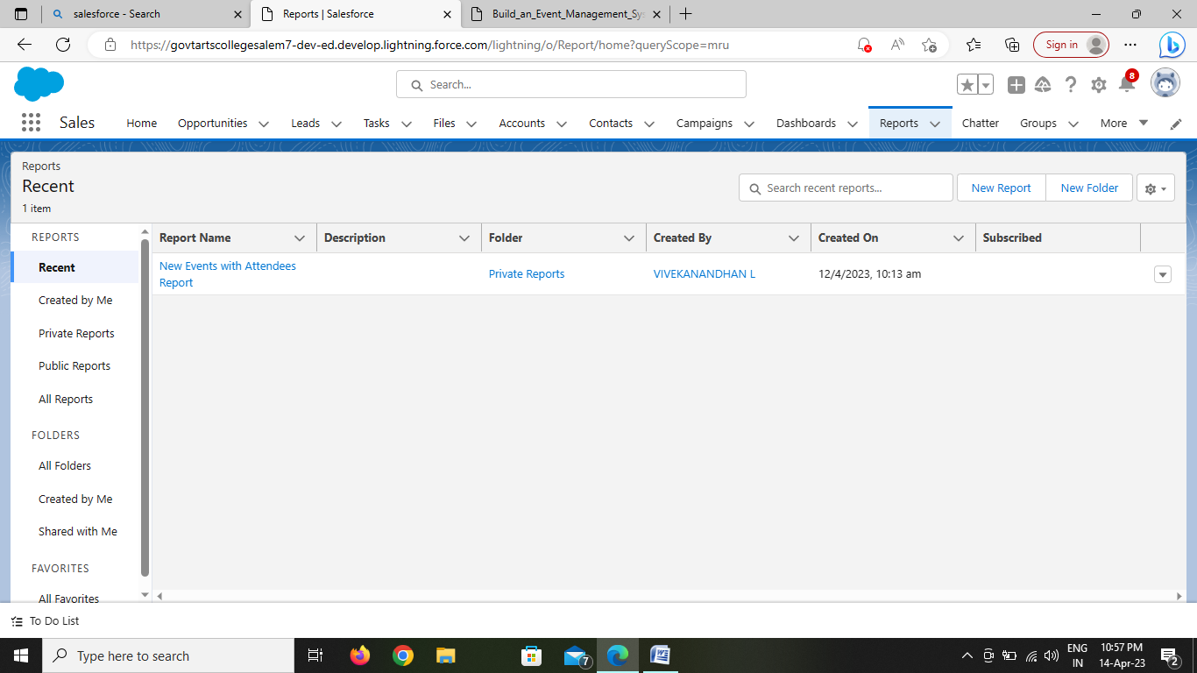

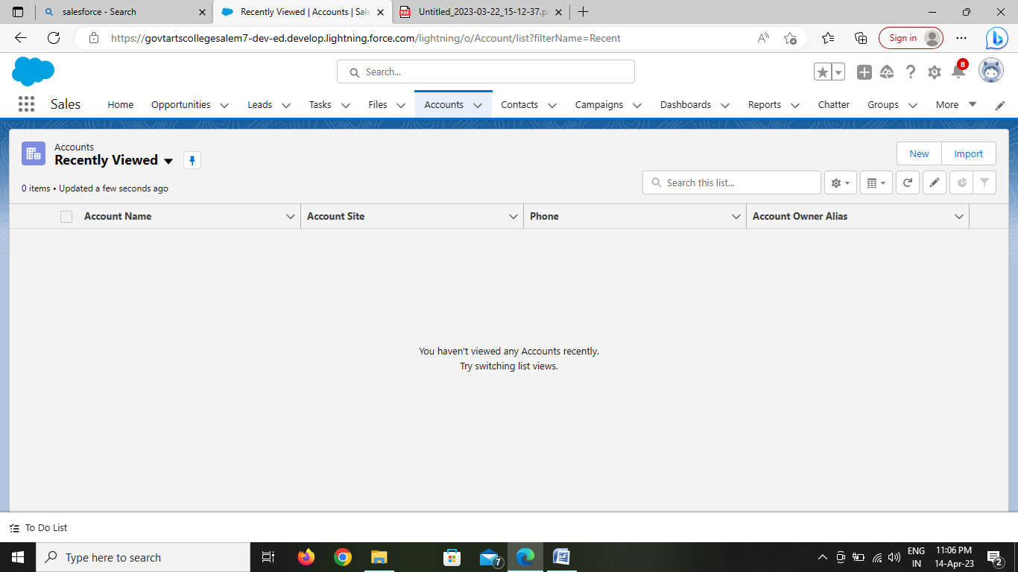

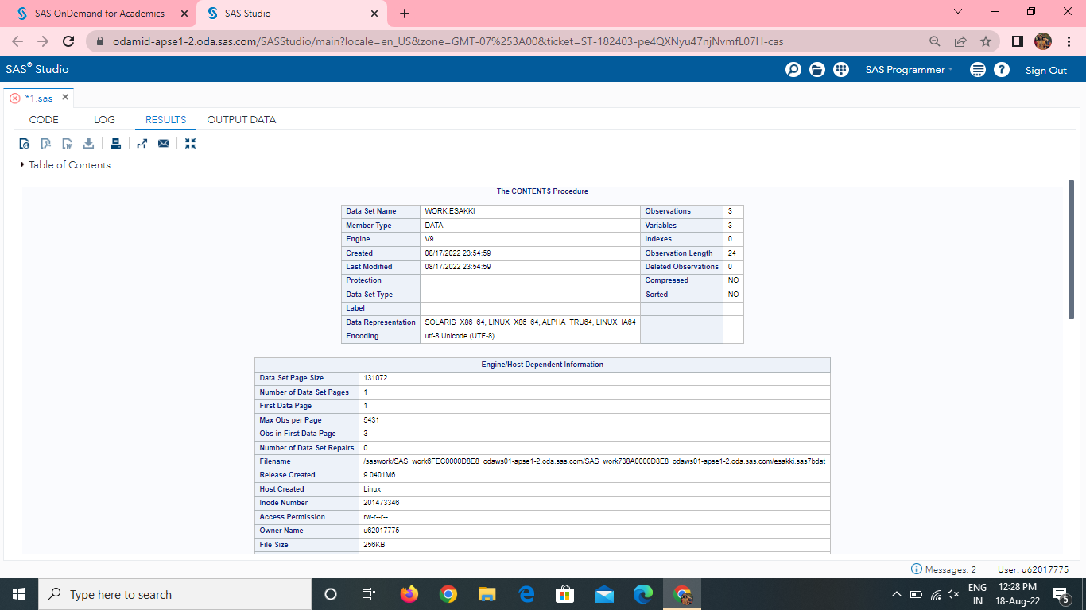

4.trailhead profile public url:

Team lead -https://trailblazer.me/id/srirs17

Team member 1 - https://trailblazer.me/id/vivel5

Team member 2 -https://trailblazer.me/id/srikn20

Team member 3 -https://trailblazer.me/id/chanm80

5. advantages:

* Improving incident detection and response times When you use an event management tool, you can improve your incident detection and response times.
* Automation capabilities that save time and costs.
* Greater visibility into IT service delivery quality .
* Better decision-making and actions through automated report distribution.
* Operational cost savings .

6. disadvantage

* **Catering Hassle**

Catering and food are one of the most important steps for any event planning. All event managers fully look into [catering options for their event](https://thecartco.com.au/), as this is what the attendees look forward to the most. Finding the right type and kind of caterer for your event is hard. Looking for someone who not only has good quality food but also sets well with the vibe of your event can be a challenge. With options like[event catering Sydney](https://pomeloandco.com.au/events/), you can now try to book the best option for your event in order to avoid any problems related to food.

* **Technology**

The issue is that with growing technology, keeping up with new things becomes a very difficult task. Monitoring social media and the relevant channels for updates can be tough. However, it is very important to keep doing that so that you can know anything and everything that might happen which can affect your event in any way. Try to think outside the box in terms of technology and use event-planning software to help you out.

* **Not Getting Right Vendors**

Getting the right network of vendors that you can trust is a huge issue. Vendors often do not deliver on their commitment, which can hinder your progress in a huge way. If you are working with someone new then the ratio of risk is also very high. Apart from not delivering on time, you can face the concern of getting the wrong things for your event. Make sure that whoever you book is experienced and right for the job

7.applications:

.

The applications of event management are ,

* Wedding
* Reception
* Birthday parties
* Company inauguration events
* Annual day events

8.conclusion

* Planning an event can be a huge thing for any event management business.
* The level of problems that it comes along with is also very hard. Try to work on all these issues mentioned above in order to avoid any major problems from arising at the end.
* Take things in a serious way so that you do not have anything to worry about in the end

9.future scope:

* Technology in events may be used in diverse ways, both conventional and new, but the future still remains unknown.
* The only valid prediction that we can make about new trends of events management industry: the future of it is mobile.

* Portable devices are going to govern interaction, registration, and promotional activities.
* By learning how to elevate your expertise and master new trends in event management, you can get ready for tomorrow.